abacus 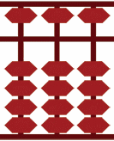 auctions
Well-known Melbourne dealer Torsten Weller has announced his acquisition of the assets of the Stamp & Coin Department of recently failed Mossgreen Auctions. With fellow ex-Mossgreen employees Gary Watson (former owner of Prestige Philately) and Nick Anning, Torsten has formed Abacus Auctions, with the somewhat cheesy but appropriate motto “You Can Count On Us!”
“People will quickly see,” said Torsten, “that we are returning to the successful and highly respected business model that made Prestige Philately a world leader in this industry. We stand for integrity and the highest professional standards, coupled with respect for all our clients and their material. Collecting stamps and coins should be fun and we want people to enjoy all their dealings with Abacus.”
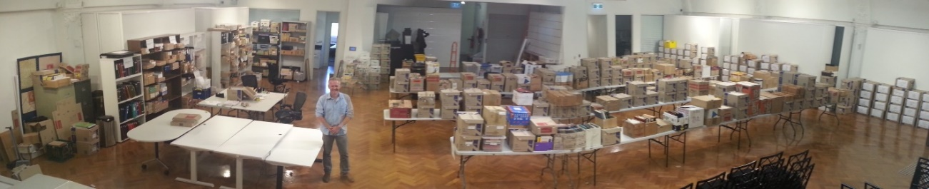
Consignments on hand for the first Abacus Auctions sale in May 2018
(not including the valuable items stored in fire-proof safes)
New Premises
Abacus Auctions has recently moved into new premises in Glen Waverley, the demographic heart of Melbourne. The location is near the corner of Blackburn and Ferntree Gully Roads, an easy 20-30 minutes from the city, and only one minute from two South-Eastern Freeway exits. Buses operate along both major roads and connect with railway services at Syndal and Blackburn.
Our First Auction
The first Abacus Auction will be conducted at our premises on Saturday 19th May 2018. The auction will include outstanding Australia and strong European content. A bower bird’s Australian Colonies accumulation is sure to attract lots of interest, as will a collection of commercial perfins on Kangaroos. A feature will be the first part of Max Watson’s extensive collection of Victorian Barred Numeral cancellations.
Over the past few weeks, Gary Watson personally contacted almost every vendor whose material was re-consigned to Abacus, and was delighted with the outpouring of support and goodwill for the new venture. “Virtually everybody I have spoken with, including some who lost significant sums of money in the Mossgreen collapse, has enthusiastically embraced what we are doing.”

At Abacus our goal is for everyone to enjoy their auction experience. Every client will be made to feel welcome, and we will be re-introducing the Prestige Philately tradition of free auction day afternoon teas. We look forward to seeing many of you at our first auction, and invite you to drop in at any time.
Reduced Commission Rates
Abacus will offer lower commissions for both buyers and sellers, with our Buyer’s Premium reduced to 19.8% inclusive of GST. Vendor rates will also include GST, as will our very modest fees for payment by credit card.
Protecting Your Money
Abacus is in the process of establishing a segregated “client trust account” for holding vendors’ money. We will be the first (and currently only) major stamp or coin auction firm in Australia to offer clients this important protection. Abacus will also lead the way by paying vendors 45 days after each auction.
Website
Our online presence will be based on the user-friendly Prestige Philately platform, with additional features. This is currently in development, but a lot of work will be required to elevate it to the desired standard. In the meantime, please enjoy accessing the “old” www.prestigephilately.com site with its numerous free resources.
Contact Abacus Auctions
For further information, including how you can consign material for our future auctions, please contact:
Torsten Weller – phone +61 (0)411 043785 - email torsten@abacusauctions.com.au
Gary Watson - phone +61 (0)400 997774 – email gary@abacusauctions.com.au
Abacus Auctions Abacus Auctions
19A Hampshire Road PO Box 296
Glen Waverley 3150 Mount Waverley 3149
AUSTRALIA AUSTRALIA

